**ASSIGNMENT DAY 10**

1. There is significant relationship between Gender and Attrition.
2. More than 50% of the employees who left the company had Job Level either 1 or 2.

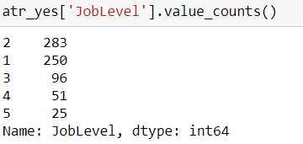

1. More than 40% of the female employees who left the company worked a greater number of years under the current manager.

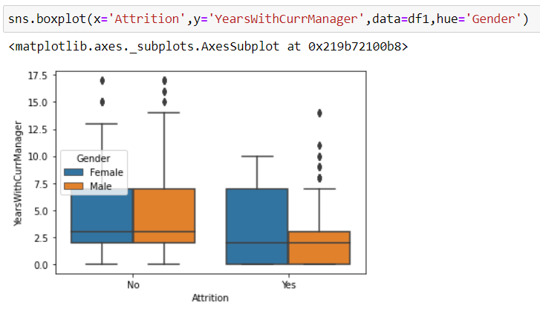

1. A greater number of female employees had more gap between the present year and the year of last promotion.

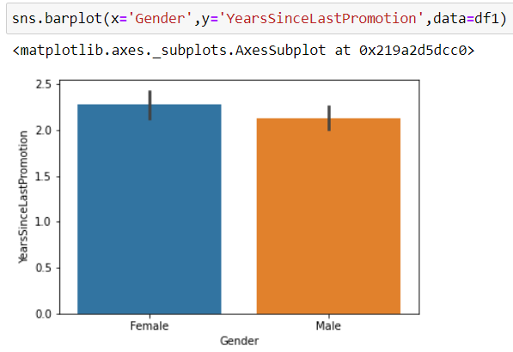

1. The monthly income of divorced female was greater than the monthly income of divorced male.

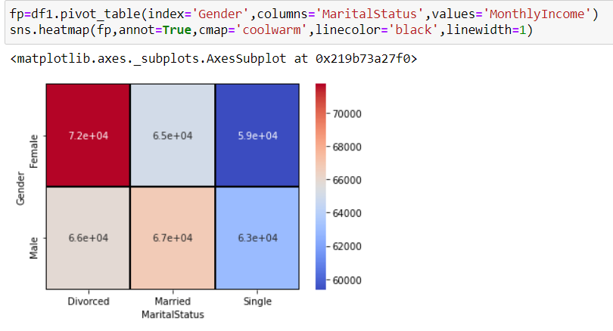

1. More than 50% of male employees who left the company had education of either ‘Bachelor’ or ‘Masters’.

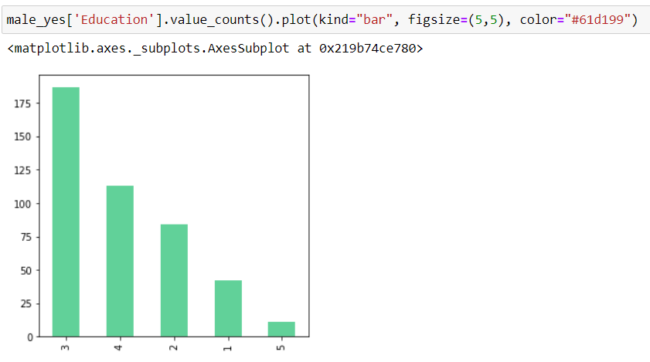

1. The mean age of all employees is 40.
2. There is correlation between Years with current manager and years at company.

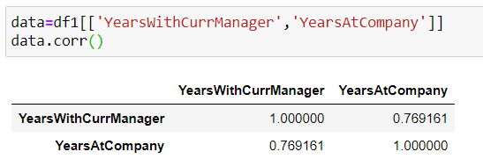

1. For 10% of employees who left the company, it had been 6 or more years since their last promotion.

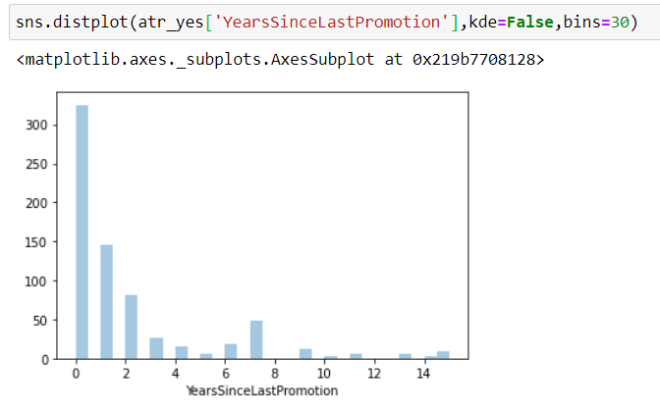

1. More than 60% employees who left the company worked in ‘Research and Development’ department.

